1. BRD — Business Requirements Document

1.1 Project Name
DevOS — AI-Powered Self-Healing Development Environment

1.2 Executive Summary
DevOS is an AI-powered development environment designed to help developers diagnose and recover broken software projects.
Modern development projects depend on multiple components such as source code, dependencies, environment variables, databases, ports, services, containers and runtime configurations. A failure in any one of these areas can prevent the application from running.
DevOS aims to provide a unified workflow in which the system understands the project, diagnoses problems using evidence, generates a recovery plan, obtains user approval, executes approved actions in a controlled environment, verifies the result and rolls back changes when recovery fails.
The core workflow is: Understand → Diagnose → Protect → Execute → Verify → Recover

1.2 Business Problem
Modern applications depend on code, dependencies, runtime, environment variables, databases, ports and services. A failure in any of these can prevent the application from running, requiring developers to manually investigate multiple tools.

1.3 Objectives
Objective | Description
Faster Diagnosis | Identify project failures using evidence
AI-Assisted Recovery | Generate recovery plans for detected issues
Safe Execution | Prevent unrestricted AI access
Verification | Confirm whether the fix actually worked
Recovery | Roll back unsuccessful changes
Auditability | Record important actions and results

1.4 Target Users
Primary: Software Developers
Secondary: Students, developer learners and engineering teams.

1.5 Product USP
DevOS combines project-state analysis, AI planning, controlled execution, verification and rollback into one recovery workflow.
Unlike a basic AI coding assistant, DevOS focuses on diagnosing and recovering the complete project environment, not just generating code.

1.6 Core Business Requirements
ID | Requirement
BR-01 | Understand project stack, dependencies, services, ports and configuration
BR-02 | Diagnose issues with evidence, severity, confidence and root cause
BR-03 | Generate AI-based recovery plans
BR-04 | Obtain user approval for impactful actions
BR-05 | Execute approved actions inside a sandbox
BR-06 | Verify fixes through build, tests, runtime and health checks
BR-07 | Roll back changes when recovery fails
BR-08 | Maintain an audit trail of system activities

1.7 MVP Scope
Included: Project Importer, Project Doctor, Process/Port Monitor, AI Planner, Docker Sandbox, Approval UI, Verification Engine and Audit Trail.
Demo: A React + Node + PostgreSQL application with intentionally introduced configuration, dependency, port, database and runtime failures.

1.8 Out of Scope
- Full IDE replacement
- Kernel-level OS development
- Multi-user collaboration
- Production deployment automation
- Every programming language
- Unrestricted host administration
- Advanced cloud management
- Fully autonomous AI execution

1.9 Success Criteria
The MVP should demonstrate that a broken project can be imported, diagnosed, planned, safely modified, verified and either recovered or rolled back, with the complete process recorded in the audit trail
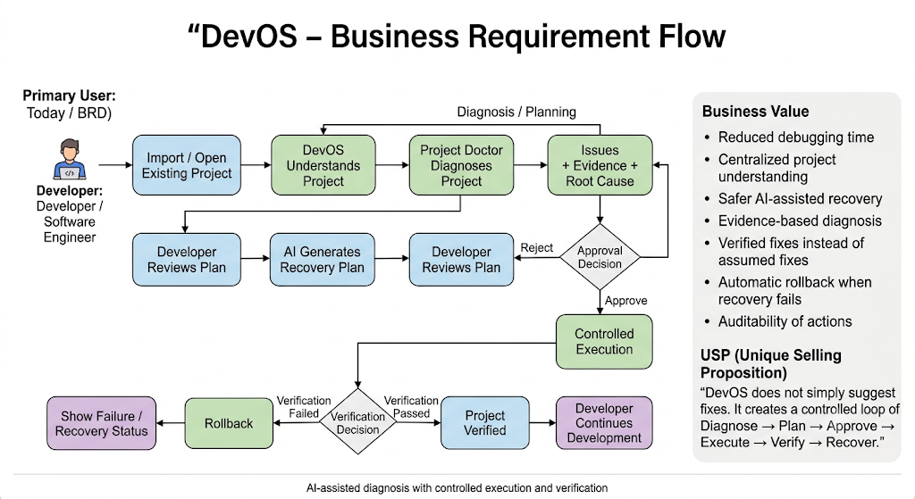
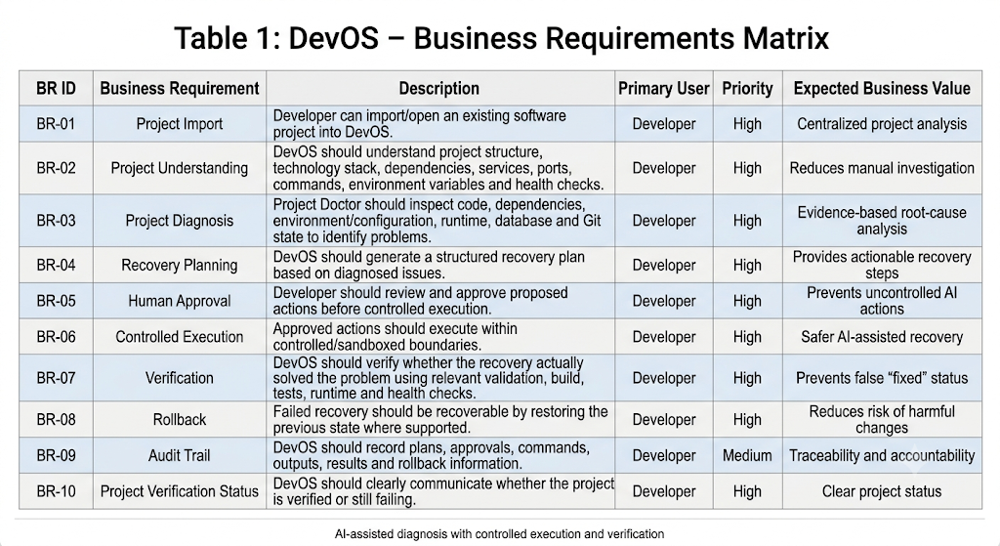

2. TRD — Technical Requirements Document

2.1 Technical Objective
The technical objective is to implement DevOS as a modular system capable of: Project Discovery → Diagnostics → AI Planning → Policy Validation → Sandboxed Execution → Verification → Rollback → Audit

2.2 High-Level Architecture
┌──────────────────┐
│ DevOS Web UI │
└────────┬─────────┘
│
▼
┌─────────────────────┐
│ DevOS Controller │
└──────────┬──────────┘
│
┌──────────────────┼──────────────────┐
▼ ▼ ▼
┌────────────────┐ ┌────────────────┐ ┌────────────────┐
│ Project │ │ Project Doctor │ │ Process/Port │
│ Importer │ │ Diagnostics │ │ Monitor │
└───────┬────────┘ └───────┬────────┘ └────────────────┘
│ │
└──────────┬───────┘
▼
┌───────────────┐
│ AI Planner │
└───────┬───────┘
▼
┌───────────────┐
│ Policy Engine │
└───────┬───────┘
▼
┌───────────────┐
│ Approval UI │
└───────┬───────┘
▼
┌───────────────┐
│ Docker │
│ Sandbox │
└───────┬───────┘
▼
┌───────────────┐
│ Verification │
│ Engine │
└───────┬───────┘
▼
┌───────────────┐
│ Rollback / │
│ Recovery │
└───────────────┘

+
┌───────────────┐
│ Audit Trail │
└───────────────┘

2.3 Technical Components
Component | Main Responsibility
Project Importer | Detects project files, framework, runtime, dependencies, configuration, Docker, database, commands and Git state.
Project Doctor | Performs deterministic checks for code, dependencies, environment, runtime, database, ports and Git.
AI Planner | Converts diagnostic findings into structured recovery plans; does not directly control the terminal.
Policy Engine | Classifies actions by risk and allows, requires approval, or blocks them.
Approval System | Shows the issue, evidence, proposed action and risk before execution.
Docker Sandbox | Runs approved actions in an isolated and controlled environment.
Verification Engine | Checks build, tests, runtime, health and logs to confirm whether the fix worked.
Rollback System | Creates recovery points and restores the previous state when verification fails.
Audit Trail | Records imports, diagnoses, plans, approvals, executions, verification and rollback events.

2.4 Technology Stack
Layer | Technology
Frontend | React / TypeScript
Backend | Python / FastAPI
AI | LLM API
Containerization | Docker
Database | PostgreSQL
Version Control | Git
Testing | Pytest
API | REST / JSON

2.5 Core Data Models
Model | Purpose
Project | Stores project details and manifest
Diagnostic | Stores detected issues and evidence
RecoveryPlan | Stores AI-generated actions and risk
Execution | Tracks sandbox execution
Verification | Stores build, test and runtime results
AuditEvent | Records system activities

2.6 API Requirements
API Area | Operations
Projects | Import, view, diagnose
Diagnostics | View findings
Plans | Generate, approve, reject
Execution | Start and monitor
Verification | Verify results
Recovery | Rollback
Audit | View project activity

2.7 Non-Functional Requirements
Area | Requirement
Security | Restricted AI access, sandboxing and approval for risky actions
Reliability | Explicit verification and rollback on failure
Performance | Progress tracking and background execution
Maintainability | Modular and independently testable components

